oracle
SQL> alter index owner.index_name rebuild nologging;

Composite index (collect information)

Best site for index study is https://planetscale.com/blog/why-isnt-mysql-using-my-index
######## Creating index on table ############
mysql> CREATE INDEX [index_name] ON [table_name] (column names)
ex mysql> CREATE INDEX ind_1 ON t_index(col4);

By default, MySQL allowed index type B-TREE

###### Drop Index ############
mysql>DROP INDEX index_name ON table_name;

Ex mysql> DROP INDEX class ON student;

######## show Index ############
mysql> SHOW INDEXES FROM table_name;

####### MySQL UNIQUE INDEX ############
mysql> CREATE UNIQUE INDEX index_name ON table_name (index_column1, index_column2,...);

####### MySQL REINDEX or Rebuild ############
mysql> REINDEX INDEX [Index_Name];
mysql> REINDEX TABLE [TableName]; or,
mysql> REINDEX TABLE [TableName]([ColumnName of the TableName]);
mysql> REINDEX DATABASE [DatabaseName];

###### How to reindex in mysql ############
Option 1) Using alter table statement
mysql> ALTER TABLE table_name ENGINE=InnoDB; (it can reindex table)
(There is no way to reindex specific index by default it reindex all in that table.)
Option 2) Dropping and recreating the specific index
mysql>SHOW INDEX FROM table_name;
mysql>DROP INDEX index_name ON table_name;
mysql> CREATE INDEX index_name ON table_name;

######## Find duplicate index in MySQL using query #######
1) MYSQL> SELECT
TABLE_SCHEMA, TABLE_NAME, INDEX_NAME, COLUMN_NAME, COUNT(*)
FROM INFORMATION_SCHEMA.STATISTICS
WHERE TABLE_SCHEMA = 'your_database_name' -- Replace with your database name
GROUP BY
TABLE_SCHEMA, TABLE_NAME, COLUMN_NAME
HAVING COUNT(*) > 1;

2) MYSQL> SHOW INDEXES FROM your_table_name;

####### optimization of table ######
MYSQL> use database name

Show Unused Space in a Table (see column Data_length,Data_free)
MYSQL> show table status like "table name" \G

Display Data_length, Data_free Column size in Megabytes

MYSQL> select table_name, round(data_length/1024/1024), round(data_free/1024/1024)
from information_schema.tables
where table_schema='<schema name>'
order by data_free desc;

Optimize a Table Using MySQL
MYSQL> OPTIMIZE TABLE table name;

MYSQL> OPTIMIZE TABLE table 1, table 2, table 3;

####### Check database/table corrupted or not ############
# mysqlcheck -u USER_NAME -p -c DATABASE_NAME (To only check)
$ mysqlcheck -u root -p -check –auto-repair <DATABASE> <TABLE> (To check and auto_repair)

# mysqlcheck -c -u USER_NAME -p --all-databases
# mysqlcheck -a DB_NAME TABLE_NAME -u USER_NAME -p

mysql>repair table DATABASENAME.TABLENAME use_frm;

mysql>CHECK TABLE table_name ;

mysql>REPAIR TABLE table_name ;

mysql>OPTIMIZE TABLE tbl;

# in mysql server when we need to optimize the table or database.
You don't necessarily need to optimize MySQL tables or databases routinely. In fact, frequent optimization can negatively impact performance.
Heavy DELETE or UPDATE operations: If you've performed a significant number of DELETE or UPDATE operations on a table, it can lead to fragmentation.
Large table size and slow queries: If you have a large table with slow queries, analyzing the queries and optimizing them (using techniques like proper indexing) is often more effective than simply optimizing the table.
Moving tables to different storage engines: When migrating tables from one storage engine (like MyISAM) to another (like InnoDB), the OPTIMIZE TABLE command might be necessary to convert the table format.

Fragmentation: In MySQL, fragmentation refers to a condition where the physical storage of a table's data becomes scattered across the disk. This can happen due to various operations like inserts, updates, and deletes.

# How to defragment a table in MySQL

OPTIMIZE TABLE
mysql> OPTIMIZE TABLE table_name;
+-----------------+----------+----------+-------------------------------------------------------------------+
| Table | Op | Msg_type | Msg_text |
+-----------------+----------+----------+-------------------------------------------------------------------+
| test.table_name | optimize | note | Table does not support optimize, doing recreate + analyze instead |
| test.table_name | optimize | status | OK |
+-----------------+----------+----------+-------------------------------------

ALTER TABLE
mysql> ALTER TABLE table_name ENGINE=engine_type;

How to identify MySQL fragmentation
Here we will use following query to identify top 10 fragmented tables and try to reclaim the space.
mysql> SELECT table_schema, table_name , (DATA_FREE)/(102410241024) as FragGB, (DATA_LENGTH+INDEX_LENGTH)/(102410241024) as totalSizeGB, (data_free/(index_length+data_length)) frag_ratio FROM information_schema.tables where data_free>0 order by 3 desc limit 10;
+--------------+------------+--------+-------------+--------------------+
| TABLE_SCHEMA | TABLE_NAME | FragGB | totalSizeGB | frag_ratio |
+--------------+------------+--------+-------------+--------------------+
| employees | table_name | 0.3936 | 0.2776 | 1.4176 |
+--------------+------------+--------+-------------+--------------------+
================================================================================
$$$ Performance Tunning
There are three types of performance tuning.
1) server level -
2) database level
3) query level

$query tunning
$database parameter setting

1) server tunning - memory, hardware, storage, cpu ..

free -g
free -m
top
df -h (storage)

server performance
sar
lscpu

2)database tunning

$ parameter which are more important to set
max_connections
innodb_buffer_pool_size (80% of total RAM)
interactive
wait_time_out (wait_time_out and interactive are dependend each other. so if you want to change value of wait_time_out you change first interactive parameter also)
connection_timeout
datadir
socket path
pid path
log file path
slow query log
log_out = TABLE / FILE / HOME
lower_case_table_names
innodb_file_per_table
max_allowed_packet
server_id
log_bin
transaction_isolation = READ COMMITED
long_query_time = 2
performance_schema = 1
tmp_table_size = 5368709120
log_bin_trust_function_creators = 1
character_set_database = utf8mb4
character_set_server = utf8mb4
character_set_client = utf8
character_set_connection = utf8
collection_server = utf8mb4_unicode_ci
collection_connection = utf8_general_ci
innodb_print_all_deadlocks = 0
innodb_lock_wait_timeout

# query tunning
Just put explain before query
explain (query) select * from ….
explain plan can also use in SELECT, UPDATE, DELETE, and REPLACE.
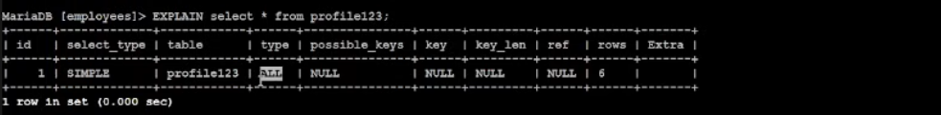
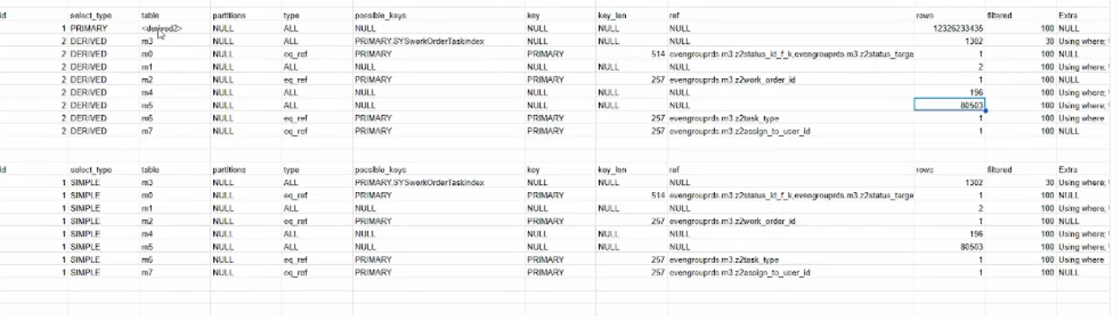

in type column it ‘ALL’ means it scan all the table.
if you have join query (means multiple tables scanning in that query) only observe type-all table
then in that type-all see rows column and analyse how much they rows scane and pick only that max rows no.
only max rows see table name in table column
and analyse that table have index or not (if not then make index on that column)
in query next to the 'from' you get table name.

possible-key is the index on that table use to this query.

Scenario 2
If in one table two different column are fetching and there varchar are different then make them same . For that follow this below document.
https://dev.mysql.com/doc/refman/8.4/en/explain-output.html
ex- mysql> ALTER TABLE tt MODIFY AssignedPC VARCHAR(15);
(tt-table namwe, AssignedPC- column name )

Obtaining Execution Plan Information for a Named Connection

mysql> SELECT CONNECTION_ID();
+-----------------+
| CONNECTION_ID() |
+-----------------+
| 373 |
+-----------------+
1 row in set (0.00 sec)

mysql> EXPLAIN FOR CONNECTION 373;
How to find out connection id of particular query
Mysql> SHOW PROCESSLIST;
And in that id is nothing but Connection id.

Scenarios 3

